  cybersecurity in agriculture training with PEDCO & UNO  When: Wednesday, March 19, 1:00 pm-2:30 pm  Where: Ponca Transit Facility  1800 Syracuse Avenue, Norfolk, NE  Hackers are getting more sophisticated, and they strike randomly. This is true even in Agriculture. Understand your options and prepare for the possibility you could be the next victim of a cybercrime. PEDCO is offering this free Cybersecurity in Agriculture training in partnership with the University of Nebraska at Omaha.  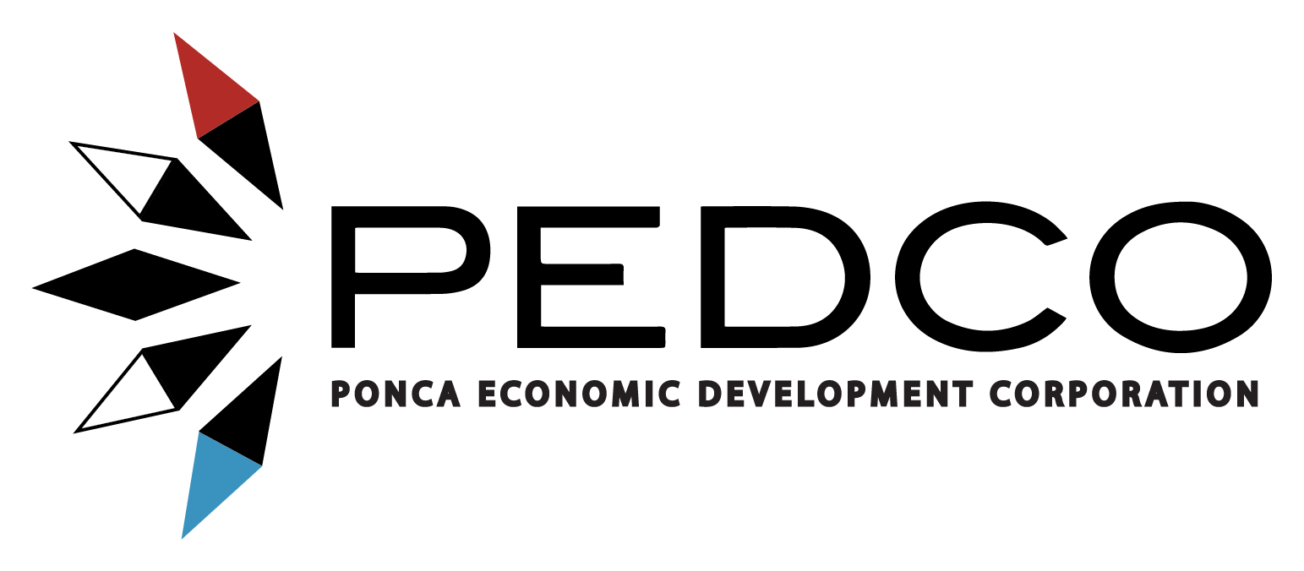 | CYBERSECURITY IN AGRICULTURE TRAINING  ____  PRESENTED BY PEDCO & UNO  ____  IN-PERSON  ____  FREE 1 ½ HOUR TRAINING  ____  OPEN TO ALL PONCA TRIBE MEMBERS  Interested?  contact  Greg Moser  Director  PEDCO  gmoser@pedco-ne.org  402-434-2127 Ext. 7

